Adding the Sherman Physician Directory to your computer and PDA

The following steps will put the physician list with specialty, address, phone and fax onto Outlook and once synced onto your PDA under the category “Sherman Doctors.” This will keep your personal contact list easily accessible and the physician list hidden until you need to access it.
If you do not use Outlook, the procedure should be easily adaptable to your contact program. Feel free to ask me for assistance. As an alternative, you may load the .xls version of the list onto desktop and your PDA by using Word, Pocket Word, or Documents To Go (depending on your operating system)

Ron Hirsch, MD

Step 1- Add Sherman Doctors as a category to your contact list

1- Open Outlook to your contact list

2- Click Edit, choose Categories
3- Click Master Category List…

4- In New Category box, type: Sherman Doctors

5- Click Add then OK.

6- Click OK on Categories Box

Step 2- Import list to Outlook

1- Click File, choose Import and Export…

2- Choose an action to perform: Choose Import from another program or file
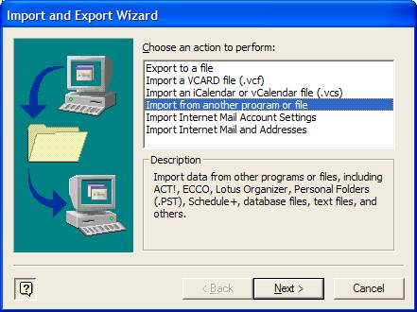
3- Click Next

4- Select file type to import from: Choose Comma Separated Values (Windows)

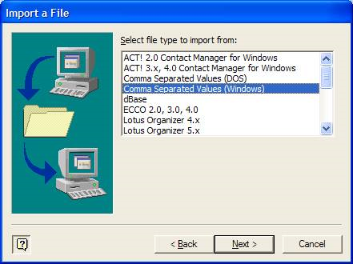

5- Click Next

6- File to Import: Click Browse and navigate to the .csv file provided to you. Do not choose the .xls version.
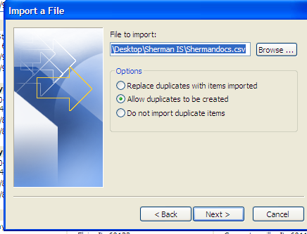

7- Click Next

8- Select destination folder: Highlight Contacts

9- Click Next

10- The following actions will be performed: Click Finish

The Physician List is now integrated into your Contact list under the Sherman Doctors category.

Hot sync your PDA. The list is now loaded on your device.

